Sorrento By the Sea

Created by: Jasmin Rose Lim

TABLE OF CONTENTS

Sorrento By the Sea 1

PROJECT SCHEDULE 3

SITEMAP 4

WIREFRAMES 5

Home 5

Contact 6

General 7

TECHNICAL SPECIFICATIONS 9

Markup Language 9

TESTING 10

Approach 10

Test Checklist 10

Test Cases - General 11

Test Case – Compatibility 15

# PROJECT SCHEDULE

|  |  |  |  |  |  |
| --- | --- | --- | --- | --- | --- |
| **TASK** | **WEEK** | **STATUS** | **DURATION** | **START** | **END** |
| Planning/Review of Client Requirements (Sitemap, Wireframe, Test Cases) | 1 | Completed | 3 | 10/01/2022 | 12/01/2022 |
| Initial Client Meeting/Sitemap Review | 1 | Completed | 1 | 13/01/2022 | 13/01/2022 |
| Sitemap Revisions and Approval | 1 | Completed | 1 | 13/01/2022 | 13/01/2022 |
| Website Design/Development | 2 | Completed | 5 | 14/01/2022 | 18/01/2022 |
| Website Testing | 3 | Completed | 3 | 18/01/2022 | 20/01/2022 |
| Client Review/Handover | 3-4 | Pending | 1 | 21/01/2022 | 21/01/2022 |

# SITEMAP

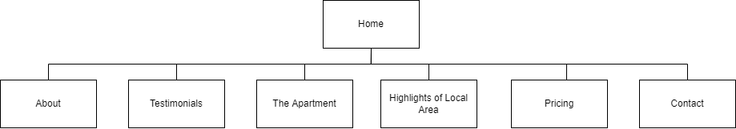

# WIREFRAMES

## Home

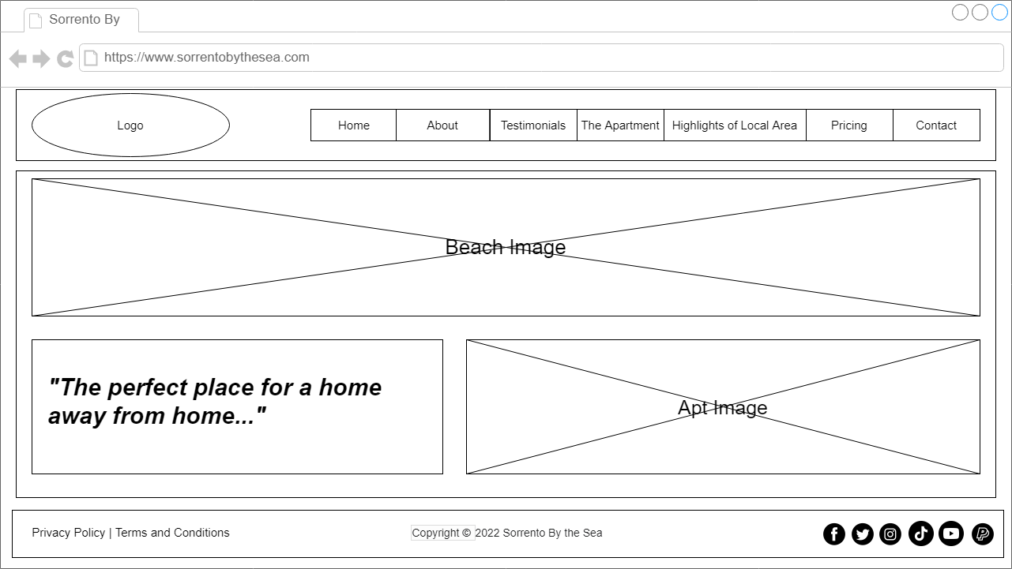

## Contact

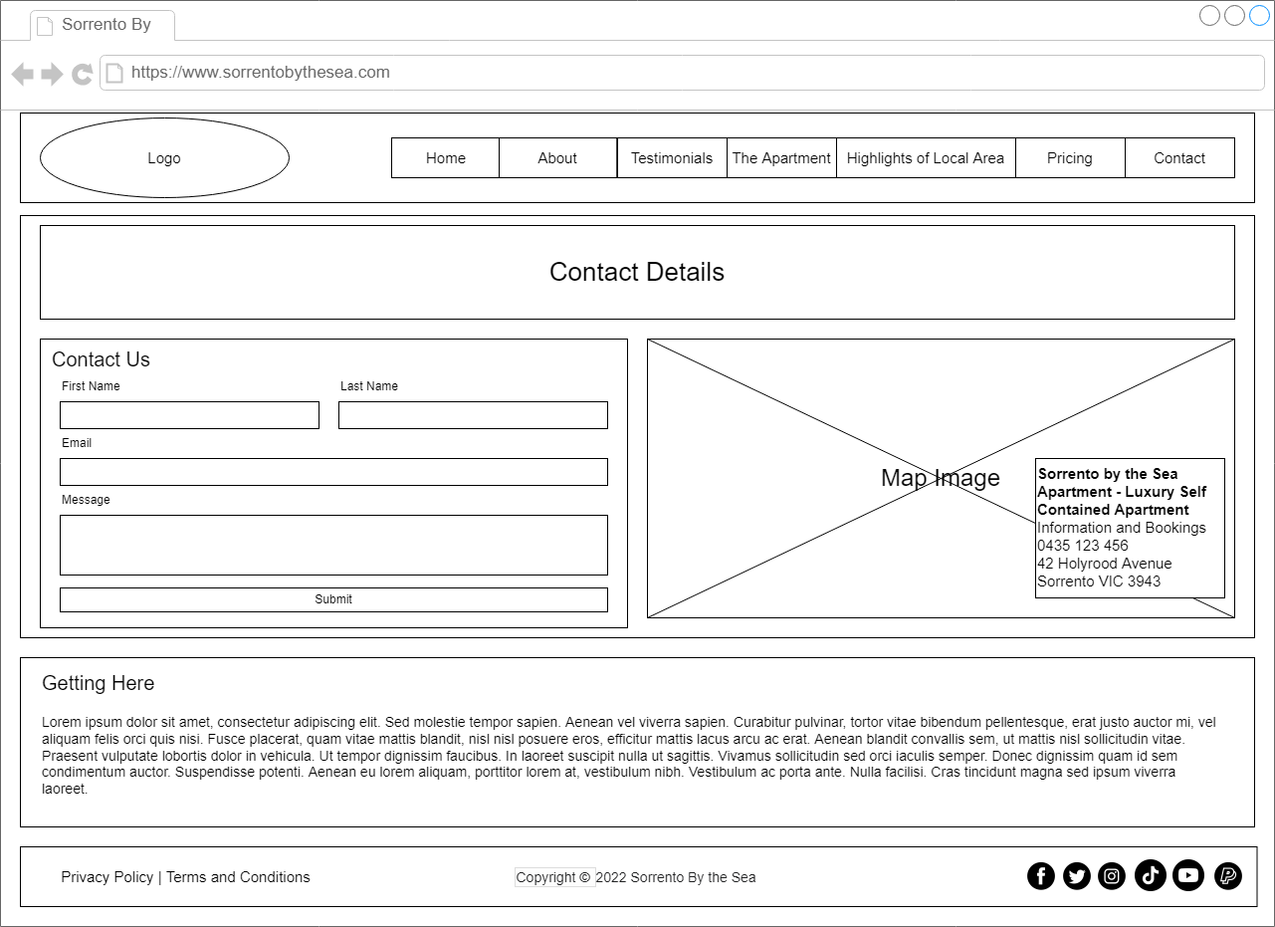

## General

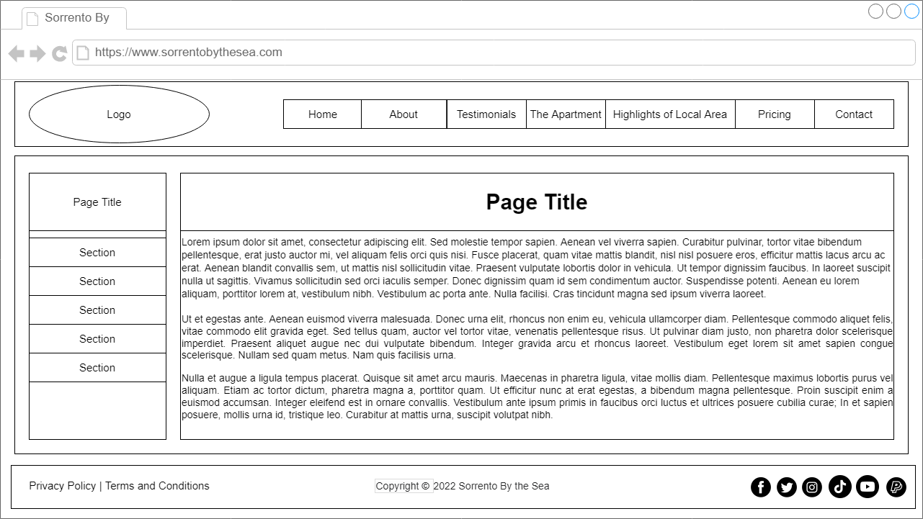

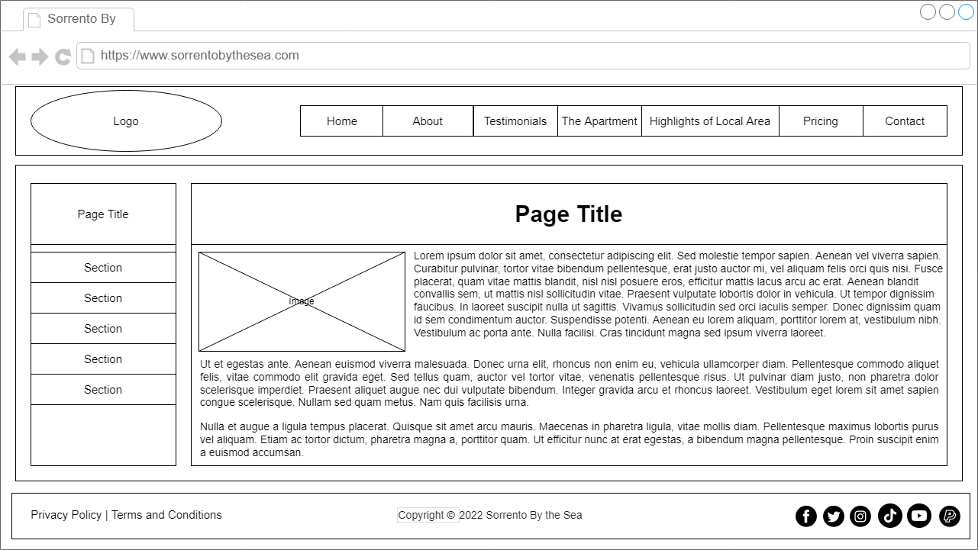

# TECHNICAL SPECIFICATIONS

|  |  |
| --- | --- |
| Feature | Associated style |
| Global font hierarchy | Helvetica, Calibri, suitable default |
| Primary navigation links | #4d1d18, remove default underline |
| Navigation hover effect | #555 |
| Major heading | #87423c, 36 pixels |
| Sub-headings | #4d1d18, 24 pixels |
| Paragraph text | 150% line height |
| Content links | #87423c |
| Footer text and links | #87423c |

## Markup Language

Dynamic HTML (DHTML)

* HTML5
* CSS3

# TESTING

## Approach

Manual Testing

Standard

* Test Checklist
* Test Cases

## Test Checklist

|  |  |  |
| --- | --- | --- |
| **ITEM** | |  | | --- | | **COMPLETED** | |
| Identification of Client Requirements | Completed |
| Test Case Creation | Completed |
| Website Development | Completed |
| Test Execution | Completed |
| Debugging | Completed |
| Acceptance and Handover |  |

## Test Cases - General

|  |  |  |  |  |  |  |
| --- | --- | --- | --- | --- | --- | --- |
| **TEST CASE ID** | **TEST CASE DESCRIPTION** | **TEST STEPS** | **EXPECTED RESULTS** | **ACTUAL RESULTS** | **PASS/FAIL** | **COMMENTS** |
| 1 | Verify logo visibility in all pages | 1. Check each page if the logo is displayed at the upper right of the page | Logo must be at the upper right corner of the page Logo: | Logo in upper right | Pass |  |
| 2 | Verify Home link visibility in all pages | 1. Check each page if the Home link is visible on the header nav links | Home link is visible in the header nav links | Home link visible in the header | Pass |  |
| 3 | Verify About link visibility in all pages | 1. Check each page if the About link is visible on the header nav links | About link is visible in the header nav links | About link visible in the header | Pass |  |
| 4 | Verify Testimonials link visibility in all pages | 1. Check each page if the Testimonials link is visible on the header nav links | Testimonials link is visible in the header nav links | Testimonials link visible in the header | Pass |  |
| 5 | Verify The Apartment link visibility in all pages | 1. Check each page if the The Apartment link is visible on the header nav links | The Apartment link is visible in the header nav links | The Apartment link visible in the header | Pass |  |
| 6 | Verify Highlights the of Local Area link visibility in all pages | 1. Check each page if the Highlights of the Local Area link is visible on the header nav links | Highlights of the Local Area link is visible in the header nav links | Highlights of the Local Area link visible in the header | Pass |  |
| 7 | Verify Pricing link visibility in all pages | 1. Check each page if the Pricing link is visible on the header nav links | Pricing link is visible in the header nav links | Pricing link visible in the header | Pass |  |
| 8 | Verify Contact link visibility in all pages | 1. Check each page if the Contact link is visible on the header nav links | Contact link is visible in the header nav links | Contact link visible in the header | Pass |  |
| 10 | Verify if Privacy Policy and Terms and Conditions link is visible in all pages | 1. Check if Privacy Policy and Terms and Conditions link is visible at the lower left part of the page in all pages | Privacy Policy and Terms and Conditions link is visible and separated with "|" symbol | Privacy Policy and Terms and Conditions link is visible | Pass |  |
| 11 | Verify if copyright is visible | 1. Check if copyright is visible at the middle part of the page in all pages | Copyright policy is written as "Copyright © 2022 Sorrento By the Sea" and at the middle part of the page | Displayed as "Copyright © 2022 Sorrento By the Sea" and at the middle part of the page | Pass |  |
| 12 | Verify if social media links are visible | 1. Check if Facebook, Twitter, Instagram, Youtube and Paypal is visible at the lower right of the page in all pages | Expected result would be in this sequence: | Displayed In this sequence and at the lower right in all pages | Pass |  |
| 13 | Verify if current page indicator displays in all pages | 1. Click any navigation link in the header 2. Check if current page navigation link is highlighted | Current page navigation link is highlighted (Provide screenshots) | Current page link is highlighted | Pass |  |
| 14 | Test logo Link | 1. Click the logo of the website in the upper left of any page | Redirect to the Home page | Logo link redirects to the Home page | Pass |  |
| 15 | Test nav links - About link | 1. Click the About link on any page | Redirect to the About page | About link redirects to the About page | Pass |  |
| 16 | Test nav links - Testimonials link | 1. Click the Testimonials link on any page | Redirect to the Testimonials page | Testimonials link redirects to the Testimonials page | Pass |  |
| 17 | Test nav links - The Apartment link | 1. Click the The Apartment link on any page | Redirect to the The Apartment page | The Apartment link redirects to the About page | Pass |  |
| 18 | Test nav links - Highlights of Local Area link | 1. Click the Highlights of Local Area link on any page | Redirect to the Highlights of Local Area page | The Highlights of the Local Area redirects to the Highlights of the Local Area page | Pass |  |
| 19 | Test nav links - Pricing link | 1. Click the Pricing link on any page | Redirect to the Pricing page | The Pricing link redirects to the Pricing page | Pass |  |
| 20 | Test nav links - Contact link | 1. Click the Contact link on any page | Redirect to the Contact page | The Contact link redirects to the Contact page | Pass |  |

## Test Case – Compatibility

|  |  |  |  |  |  |  |
| --- | --- | --- | --- | --- | --- | --- |
| **TEST CASE ID** | **TEST CASE DESCRIPTION** | **TEST STEPS** | **EXPECTED RESULTS** | **ACTUAL RESULTS** | **PASS/FAIL** | **COMMENTS** |
| 1 | Test Home page using Google Chrome and Firefox | 1. Open the website using Google Chrome and Firefox 2. Navigate to the Home page 3. With a browser screenshot tool, capture the full width of the page in Chrome and Firefox respectively | Home page displays consistently in both web browsers (Provide Screenshots) | Displays consistently  Chrome:  fullpagescreenshot  Firefox:  fullpagescreenshot | Pass |  |
| 2 | Test About page using Google Chrome and Firefox | 1. Open the website using Google Chrome and Firefox 2. Navigate to the About page 3. With a browser screenshot tool, capture the full width of the page in Chrome and Firefox respectively | About page displays consistently in both web browsers (Provide Screenshots) | Displays consistently  Chrome:  fullpagescreenshot  Firefox:  fullpagescreenshot | Pass |  |
| 3 | Test Testimonials page using Google Chrome and Firefox | 1. Open the website using Google Chrome and Firefox 2. Navigate to the Testimonials page 3. With a browser screenshot tool, capture the full width of the page in Chrome and Firefox respectively | Testimonials page displays consistently in both web browsers (Provide Screenshots) | Displays consistently  Chrome:  fullpagescreenshot  Firefox:  fullpagescreenshot | Pass |  |
| 4 | Test The Apartment page using Google Chrome and Firefox | 1. Open the website using Google Chrome and Firefox 2. Navigate to the The Apartment page 3. With a browser screenshot tool, capture the full width of the page in Chrome and Firefox respectively | The Apartment page displays consistently in both web browsers (Provide Screenshots) | Displays consistently  Chrome:  fullpagescreenshot  Firefox:  fullpagescreenshot | Pass |  |
| 5 | Test Highlights of Local Area page using Google Chrome and Firefox | 1. Open the website using Google Chrome and Firefox 2. Navigate to the Highlights of Local Area page 3. With a browser screenshot tool, capture the full width of the page in Chrome and Firefox respectively | Highlights of Local Area page displays consistently in both web browsers (Provide Screenshots) | Displays consistently  Chrome:  fullpagescreenshot  Firefox:  fullpagescreenshot | Pass |  |
| 6 | Test Pricing page using Google Chrome and Firefox | 1. Open the website using Google Chrome and Firefox 2. Navigate to the Pricing page 3. With a browser screenshot tool, capture the full width of the page in Chrome and Firefox respectively | Pricing page displays consistently in both web browsers (Provide Screenshots) | Displays consistently  Chrome:  fullpagescreenshot  Firefox:  fullpagescreenshot | Pass |  |
| 7 | Test Contact page using Google Chrome and Firefox | 1. Open the website using Google Chrome and Firefox 2. Navigate to the Contact page 3. With a browser screenshot tool, capture the full width of the page in Chrome and Firefox respectively | Contact page displays consistently in both web browsers (Provide Screenshots) | Displays consistently  Chrome:    Firefox: | Pass |  |

## Test Case – Web Standards

|  |  |  |  |  |  |  |
| --- | --- | --- | --- | --- | --- | --- |
| **TEST CASE ID** | **TEST CASE DESCRIPTION** | **TEST STEPS** | **EXPECTED RESULTS** | **ACTUAL RESULTS** | **PASS/FAIL** | **COMMENTS** |
| 1 | Validate HTML in W3C Validator Service | 1. Navigate to the W3C HTML Checker https://validator.w3.org/ 2. Upload each HTML page in the website to the validator 3. Check the result and correct any errors if raised | No errors caught by the validator (Provide screenshots) | Home page:  About Page:    Contact Page:    Highlights:    Pricing:    Testimonials:    The Apartment: | Pass | Contact Page Error:    Fixed by adding id=”message”  in textarea tag  The Apartment Area Error:    Fixed by removing unclosed </p> tag |
| 2 | Validate CSS in W3C Validator Service | 1. Navigate to the W3C CSS Checker https://jigsaw.w3.org/css-validator/ 2. Upload CSS file of the website 3. Check the result and correct any errors if raised | No errors caught by the validator (Provide screenshots) | No errors found | Pass |  |